**Assignment - 3**

**SEABORN AND THE HEATMAP**

**Code :**

import pandas as pd

import seaborn as sns

df1=pd.read_csv('gapminder-FiveYearData.csv') #reads the csv file

#print(df1)

#print(df1.duplicated().value_counts())

#checks the duplicate values and counts

df2=df1[['continent','year','lifeExp']]

#extract the needed columns from the dataset

#print(df2)

df3=pd.pivot_table(df2,index='continent',columns='year',values='lifeExp') #create a pivot table

print(df3)

sns.heatmap(df3,annot=True).get_figure().savefig('HeatMap.png')

#creates a heatmap of the pivot table and saves the figure

**Output :**

year 1952 1957 1962 ... 1997 2002 2007

continent ...

Africa 39.135500 41.266346 43.319442 ... 53.598269 53.325231 54.806038

Americas 53.279840 55.960280 58.398760 ... 71.150480 72.422040 73.608120

Asia 46.314394 49.318544 51.563223 ... 68.020515 69.233879 70.728485

Europe 64.408500 66.703067 68.539233 ... 75.505167 76.700600 77.648600

Oceania 69.255000 70.295000 71.085000 ... 78.190000 79.740000 80.719500

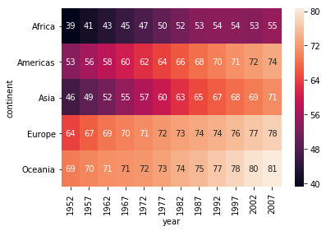

Here we read the dataset using **read_csv()** of pandas. Since the Data Set was very vast, I examined it to check if there are any duplicate values. Luckily, there were no duplicate values.Extracted the requires columns **(continent, year and lifeExp)** from the dataset into a new dataset(df2). Created a pivot table from that DataFrame(df2) with **index=continent, columns=year and values=lifeExp.**  
Heatmap of the pivot table DataFrame was plotted using **headmap()** function of **seaborn**. The heatmap figure was saved as HeatMap.png using the **savefig()**.

**annot** - denotes annotion.